WHOIS

🌐 What Is WHOIS?
# Source: AI Source: Provided by: [Data Path: Persons Table -> ID Column: 1, Name_En Column: Motasem Essam] -> From: [ChatGPT] on [1/16/2026]
WHOIS is a public internet lookup service used to find ownership, registration, and contact information for domain names, IP addresses, and Autonomous System Numbers (ASNs). It tells you who owns what on the internet.

🧠 Simple Definition:
# Source: AI Source: Provided by: [Data Path: Persons Table -> ID Column: 1, Name_En Column: Motasem Essam] -> From: [ChatGPT] on [1/16/2026]
WHOIS is like an online phonebook for internet resources — it shows who registered a domain or IP, when, where, and how to contact them.

🔗 What Can WHOIS Look Up?
# Source: AI Source: Provided by: [Data Path: Persons Table -> ID Column: 1, Name_En Column: Motasem Essam] -> From: [ChatGPT] on [1/16/2026]
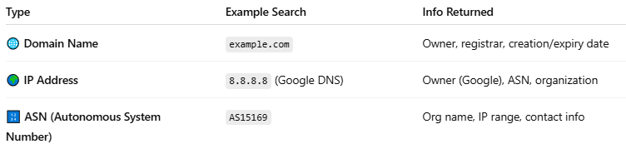

Type | Example Search | Info Returned
🌐 Domain Name | example.com | Owner, registrar, creation/expiry date
🌍 IP Address | 8.8.8.8 (Google DNS) | Owner (Google), ASN, organization
🔢 ASN (Autonomous System Number) | AS15169 | Org name, IP range, contact info

📜 Sample WHOIS Domain Result
# Source: AI Source: Provided by: [Data Path: Persons Table -> ID Column: 1, Name_En Column: Motasem Essam] -> From: [ChatGPT] on [1/16/2026]
For example.com:
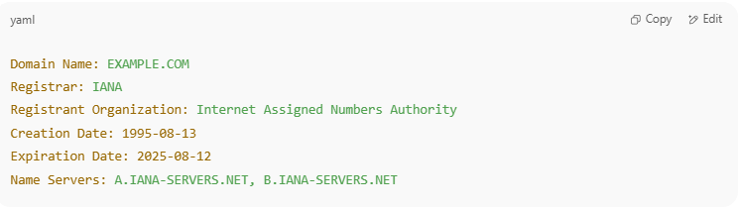
Domain Name: EXAMPLE.COM
Registrar: IANA
Registrant Organization: Internet Assigned Numbers Authority
Creation Date: 1995-08-13
Expiration Date: 2025-08-12
Name Servers: A.IANA-SERVERS.NET, B.IANA-SERVERS.NET

🧾 Sample WHOIS IP Result (via ARIN)
# Source: AI Source: Provided by: [Data Path: Persons Table -> ID Column: 1, Name_En Column: Motasem Essam] -> From: [ChatGPT] on [1/16/2026]
For IP 8.8.8.8:
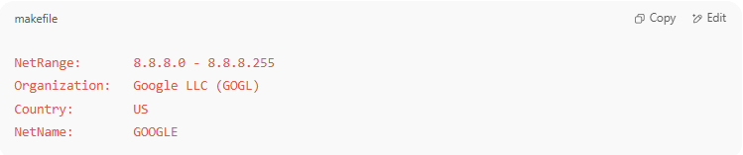
NetRange: 8.8.8.0 - 8.8.8.255
Organization: Google LLC (GOGL)
Country: US
NetName: GOOGLE

🛠️ WHOIS Lookup Tools
# Source: AI Source: Provided by: [Data Path: Persons Table -> ID Column: 1, Name_En Column: Motasem Essam] -> From: [ChatGPT] on [1/16/2026]
You can use:
- https://whois.domaintools.com
- https://whois.arin.net
- whois command in Linux/macOS terminal:
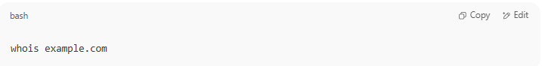
whois example.com

🔐 Can WHOIS Be Private?
# Source: AI Source: Provided by: [Data Path: Persons Table -> ID Column: 1, Name_En Column: Motasem Essam] -> From: [ChatGPT] on [1/16/2026]
Yes. Many domain registrars offer WHOIS privacy protection, which hides the registrant’s name and contact info to protect against spam or harassment.

✅ Summary
# Source: AI Source: Provided by: [Data Path: Persons Table -> ID Column: 1, Name_En Column: Motasem Essam] -> From: [ChatGPT] on [1/16/2026]
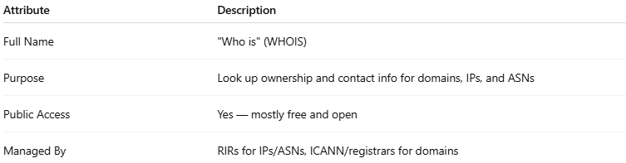

Attribute | Description
Full Name | "Who is" (WHOIS)
Purpose | Look up ownership and contact info for domains, IPs, and ASNs
Public Access | Yes — mostly free and open
Managed By | RIRs for IPs/ASNs, ICANN/registrars for domains

